Blue Mountains (and other Sandstones)

The Hawkesbury Sandstone is a very important element of the NSW geological structure. It not only comprises the Blue Mountains, but some other sectors of the Dividing Range and certainly outcrops in the Sydney region. Caves have arisen in a variety of ways, including perhaps some karstic solution, but also opening up of joints, collapse of small overhangs, stream erosion and wind sculpture.

Named Caves include:
Arch Cave
Bride and Bridegroom Cave
Bushrangers Cave
Coxs Cave
Fairy Bower
Fern Grotto
Ferris Cave
Mermaid’s Cave
Ross Caves
The Tunnel
Underground River
Veras Grotto
Walls Cave
Winnies Grotto
York Cave

1. KERRY UN-NUMBERED CARDS [n.l. 1906]

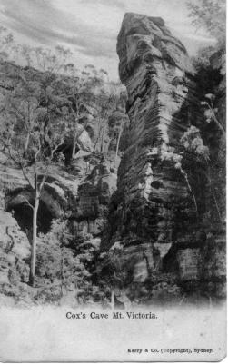 | Ph Charles Kerry  Pu Kerry & Co.  Pr In Germany by Collotype  F Photo with title in wide margin at lower edge, printed  in B. & W. (A) or Colour (B). Undivided back.  1A.1 Cox's Cave, Mt. Victoria. V [pm. 16 Jul.1906]  1A.2 Fern Grotto, Leura V [pm.24 June 1905]  1B.1 Cox's Cave, Mt. Victoria. V [pm. 23 Dec.1906]

2. KERRY SERIES 3 (Blue Mountains B)
Ph Charles Kerry
Pu Kerry & Co.
Pr In Germany by Collotype
F Hand-coloured photo with title in wide margin at lower
edge, series title on back ; divided back.
2.1 Cox's Cave, Mt. Victoria. V

3. KERRY SERIES 91

Ph Charles Kerry
Pu Kerry & Co.
Pr in Germany by Collotype
F Normal Kerry format with title & imprint in white
strip at bottom of card
1.1 Mermaids Cave, Katoomba V (Back has control mark 247696 in stamp box)
1.2 as 1.1 but control mark is V59956.

4. KERRY SERIES 94

Ph Charles Kerry
Pu Kerry & Son
Pr in Germany by Collotype
F Usual Kerry style with title and imprint in medium
lower margin; back in green

4. Path to Wall's Cave, Blackheath V (control mark in stamp box is 59989)
4. as 9.1 but control mark is 247729.

5. ROSE SERIES

Pu Rose Stereograph Co., Armadale
F Normal Rose format
5.P5258 Wall's Cave, Blackheath, Blue Mts., N.S.W. H R2a, R3
5.P5342 Looking from Cox's Cave, Mt. Victoria, N.S.W. *
5.P5345 Cox's Cave, Mt. Victoria, Blue Mts. V R2a, R4
5.P5355 Looking from Bushrangers' Cave *
5.P5368 Ross' Cave, Mt. Victoria, Blue Mts. *
5.P6203 The Mermaids Cave, Blackheath, N.S.W. V *
5.P6232 Ferns at Vera’s Grotto, Katoomba, N.S.W. R5
6. PHILLIPS SERIES.

Ph, Pu & Pr Harry Phillips, Katoomba

F Coloured half-tone print with bold title and number in lower margin.
6.1 110 Winnie's Grotto, Leura V (on small “See Australia First” back)
6.2 Winnie's Grotto, Leura V (on large “See Australia First” back)
  - Three Sisters, from York Cave, Katoomba V (on small “See Australia First”
back)
F Sepia Real Photo with title in lower margin; on blue three sisters back
  - Underground River, Medlow Bath V [pm. 3 Nov 1913]

Probably the best known of the sandstone caves in the Blue Mountains is Wall's Cave, near Blackheath. Recent investigations have shown that Aboriginal people from some 12,000 years ago used it as a living shelter.

7. SWAIN & CO. SERIES [1904>]

At least eight different cards were published by Swain & Co., Sydney. (Cook 1986, p. 151) Five of these show the exterior view - a broad and open shelter with trees in the foreground, while three show the Underground River, situated just down hill from
Wall's Cave on Greaves Creek.

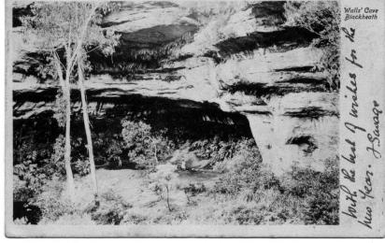  7.1 | 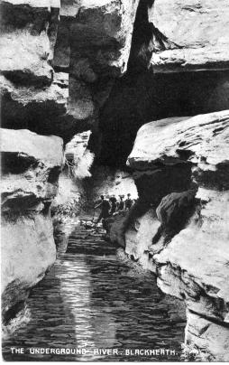 7.7

7.1 With white margin all round, wider on the R.H. end, where the title appears as
'Walls' Cave/Blackheath'. Undivided back with imprint. H [pm. 21 Dec.1904]
  - With wide white margin on lower edge only; imprint and title in single line of
print, reads 'Wall's Caves, Blackheath - Blue Mountains, N.S.W.' H
(s.n.a. 7.1)[pm.3 Sep.1904]
  - Title - 'Wall's Cave, Blackheath' - in single line superimposed on view. Divided
back. Printed in Germany; control mark 72212. H (s.n.a. 1.1)
  - Title - 'Wall's Cave, Blackheath' - in single line superimposed on view. Divided
back. Printed in Germany; control mark 155/113203 H (s.n.a. 1.1)
  - Title is 'Walls' Cave - Blackheath' in narrow white margin at bottom of card.
Divided back with publisher imprint ; control mark 155/113101 H (s.n.a. 1.1)
[pm.13 Apr.1909]
7.6a Depicts underground river. B & W with medium white margin on lower edge
only ; title - 'Walls Caves - Blackheath' - in single line of print. Divided back.
Printed in Germany; control mark 155/113103 in stamp box. V [pm.21 Jan.1908]
7.6b as above but coloured [pm.20 Nov.1909]
  - Depicts underground river. Medium white margin all round with somewhat wider
margin carrying title 'Walls Caves - Blackheath' on lower edge. Undivided back as
1.1. (s.n.a. 1.5)
7.8a Depicts underground river. No margins; superimposed title in white reads 'The
Underground River. Blackheath.' V On Swain divided back [pm.16 May 1906]
7.8b SAME, but on divided back with control 155/113207 in stamp box. Also has
W.T.P. emblem but this has been overprinted. [pm.17 Jan.1912]

8. NEATE BROS. SERIES [n.l. 1914]

Pu Neate Bros., Blackheath
Pr in Prussia

F Full-frame view with superimposed title.
8.1 Wall's Cave, Blackheath, N.S.W. H [pm.19 Apr.1914]

Blackheath postcard series
Ph P. Shier
Pu Neate Bros.
F Undivided back ; Title in wide R.H. or lower margin.
8.2 Wall's Cave, Blackheath, Blue Mountains, N.S.W. H
8.3 Approach to Wall's Cave, Blackheath, N.S.W. V [pm.3 Jan.1906] B & W

F Divided back ; Title in wide R.H. or lower margin
8.4 Approach to Wall's Cave, Blackheath, N.S.W. V [pm.3 Jan.1906] B & W
8.5 Wall's Cave, Blackheath, N.S.W. H [pm.13 Apr.1914]
Wall's Cave, Blackheath, N.S.W. H [pm. 25 Aug. 1915]

F Divided Back; Italic Title superimposed on view
8.6 Wall’s Cave, Blackheath, N.S.W. H [pm. 25 Aug 1915]

F Divided back; Title in wide lower margin
8.7 Approach to Wall's Cave, Blackheath, /Blue Mountains N.S.W. V (coloured)
8.8 Approach to Wall's Cave, Blackheath, Blue Mountains, N.S.W. V

9. NEATE BROS. / CROWN STUDIOS SERIES

Pu Card bears imprint of both Neate Bros and Crown Studios, Sydney.
Ph Crown Studios
F Photograph within broad white margins

9.1 Wall's Cave, Blackheath 115 V [pm.10 May 1908]

10. BROADHURST REAL PHOTO SERIES

Pu Broadhurst, Alt St., Ashfield, N.S.W.
F Real photo with superimposed title ; imprint is rubber-stamped on back

10.2 (Hand-coloured) Wall's Cave / Blackheath H

11. A.G. FOWLER SERIES. [n.l. 1905]

Ph A.G. Fowler, Leura, N.S.W.
F B. & W. photogravure with wide margins; title and imprint in lower margin.
11.1 "The Tunnel," Leura V [pm.10 Mar.1905]
11.2 Entrance to "Bride and Bridegroom's Cave", Fern Gully,
Leura V

12. HALL & CO. SERIES

Pu Hall & Co., Sydney
F Collotype card with title in narrow white lower margin and also superimposed on
picture with imprint

12.1 Maxine's Bower Cave, Medlow Bath, Australia H

13. S.W. NATURE SERIES.

Pu Samuel Wood (Cook 1986, pp. 155-6)
Pr in Saxony
F Full-colour print with superimposed title in white
Italics.

13.1 In Wall's Cave, Blackheath H

14. N.S.W. RAILWAYS SERIES

Pu N.S.W. Railways, in 1906.
F Photogravure with title in lower margin; back has impressed stamp (1d. red, State
Arms) and printed correspondence acknowledgement form.

  - ARCH CAVE Wentworth Falls (2844 feet above Sea Level) From Sydney, 61
miles. V [pm.3 Feb.1909]

15. KEY'S PHOTO SERIES.

Pu Key's Photo, North Sydney
F Print with wide white margins ; title and imprint superimposed.

15.1 Wentworth, N.S.W. V (depicts path through archway) [pm.20 Mar.1906]
imprint superimposed.

16. VALENTINE SERIES

Pu Valentine
Pr in Australia

16.5235 A View at Ross Caves, Mt Victoria, N.S.W. v7

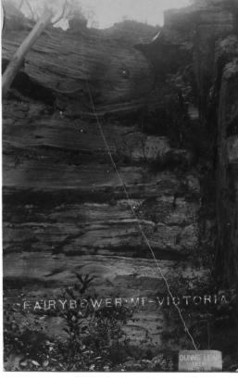  One copy of this card fortunately has the background story written by the sender: "On the other side, you will see the scene of an accident. C. Dunn, brother of Arthur Dunn of Frederickton on the MacLeay, fell down. The wire is stretched where he fell without a break. The top is near Ferris Cave, the bottom near Cox Cave. Beyond a few bruises, the boy was not hurt. He walked home, while his mates were looking for his remains." | 17. DUNNS LEAP  We now come to two remarkably distinctive cards, which belong in this location, but are rather different to the normal cave views.  F Full-frame real photo with  superimposed title  Ph L.H. Howells, Mt Victoria  17.1 Fairy Bower. Mt - Victoria V [Picture also includes tablet inscribed 'Dunn's Leap/181 ft/10-5-08'] [pm.3 Sep.1908]  17.2 Fairy Bower. Mt - Victoria V

Aboriginal Art

Throughout the sandstone regions walls of some caves or rock shelters were decorated with paintings or engravings by the Aboriginal people.

23. Although we cannot identify the publisher, these cards are important

F Half-tone print with wide but uneven margins and title printed in lower margin.

  - The Devil's Fingerprints, Shoalhaven, N.S.W. H (depicts two men examining
paintings on roof of rock-shelter.)
  - The Devil's Hand-prints, Shoalhaven, N.S.W. H (same picture as 1.1) [pm.29
Sep.1906]

Finally, there are the cards of unknown provenance.

- Cox’s Cave, Fairy Bower/Mt. Victoria V (A photogravure card with an ornate title somewhat like that of the Comet-asterisk series, Jenolan 2.14. however, it is not from this series and has the initials LHH on the card.)
- Three real photo cards:
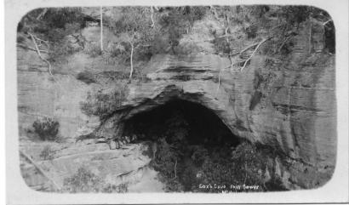
  - Cox’s Cave/Fairy Bower V on K-D(8);
  - Same title & format on K-D (X);
  - Cox’s Cave Fairy Bower/ Mt. Victoria on K-D
- Two cards, real photo with medium border all round, fine line frame between photograph & margin ; title in lower margin. Back is ornate but not identified and undivided. Both depict the Underground River rather than Wall's Cave.
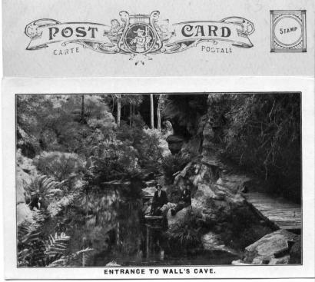

  - Entrance to Wall’s Cave H
  - Underground River V
o Bushrangers Cave / Mt Victoria K-D(O)

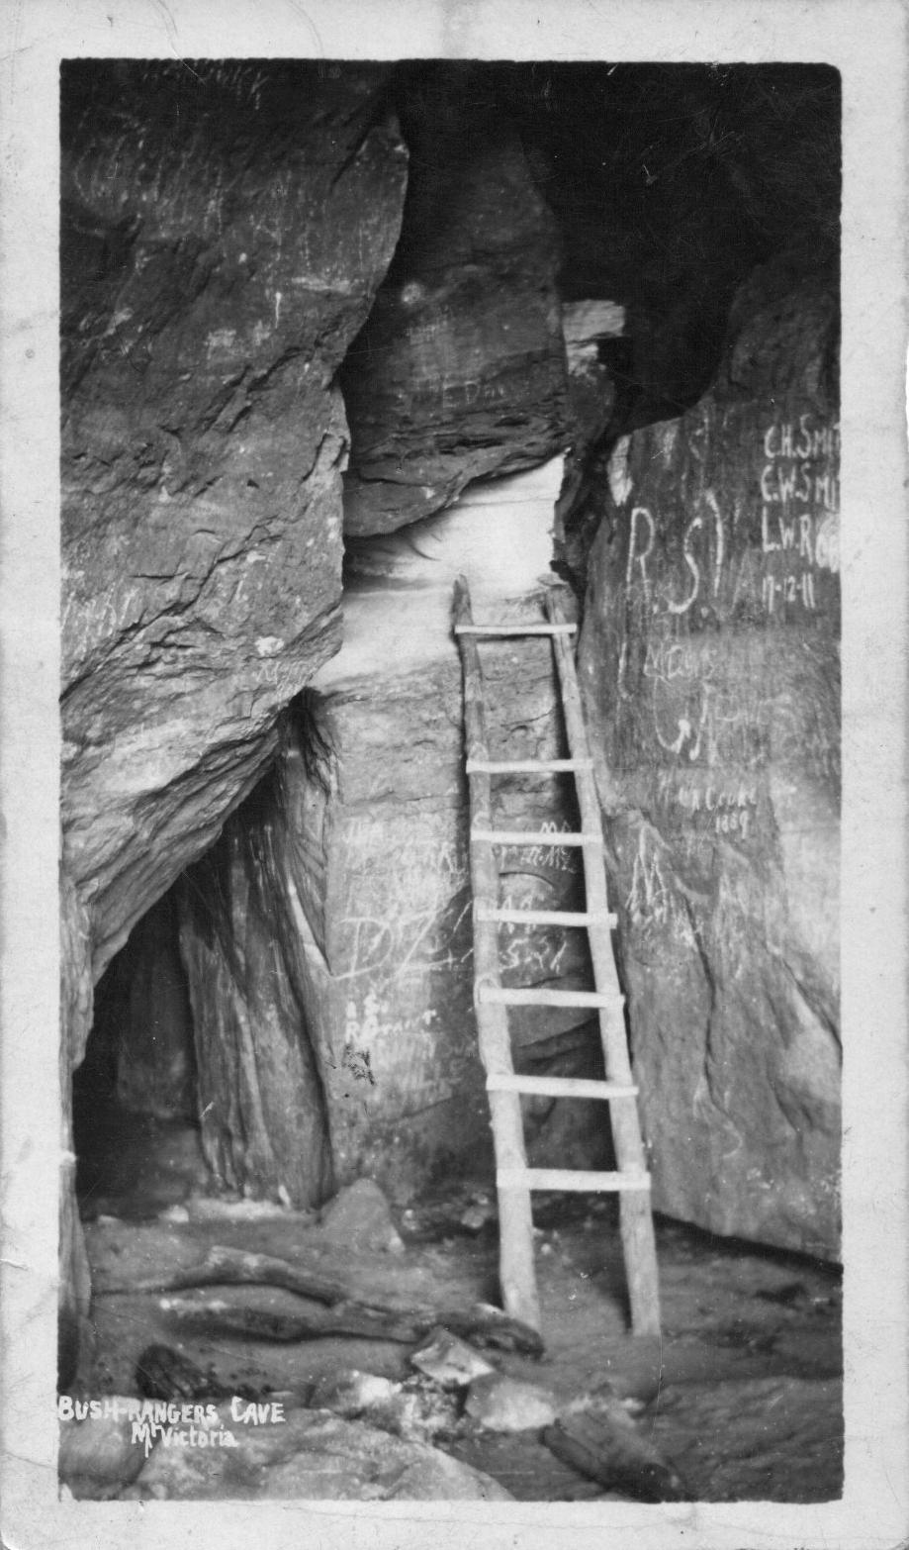

- An obvious personal photograph, depicting a couple with a little girl, all dressed in "best" clothes, standing at the foot of the steps leading to the (signposted) Bride and Bridegroom's Cave, which was located on the visitor trackway near the Leura falls. | 